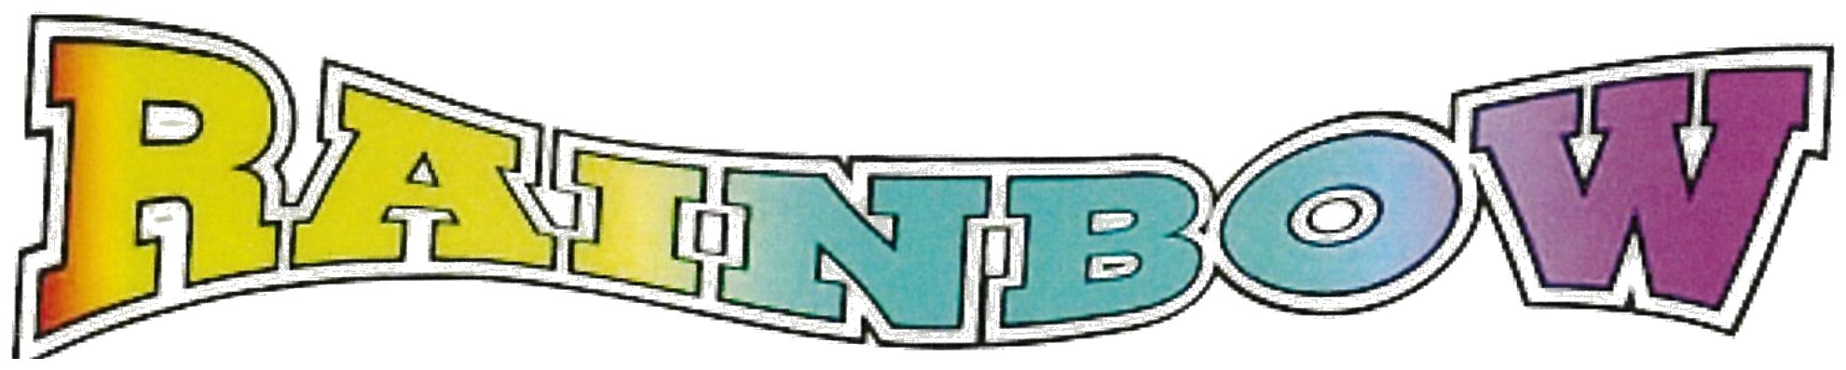
PRINTING & OFFICE SUPPLY
(775) 831-2276 • FAX (775) 831-5535
917 TAHOE BLVD., SUITE 103 • BOX 5488 • INCLINE VILLAGE, NV 89451
Prices for Printing Vinyl Banners, Foam Core,
Aluminum Sandwich Boards, Coroplast Signs
and Car Magnets from 4-Over

Banners |  | $4.00 Per Sq. Ft.
Waterproof, durable 13 oz scrim vinyl
Economical, light 8 oz mesh vinyl |  | $4.00 Per Sq. Ft.
Foam Core |  | $12.00 Per Sq. Ft.
18" x 24" |  | $36.00 each
24" x 36" |  | $72.00 each
4 mm Coroplast |  | $10.95 Per Sq. Ft.
Waterproof, lightweight, traditional yard signs
18" x 24" |  | $32.85 each
24" x 36" |  | $65.70 each
Aluminum Sandwich Boards |  | $24.00 Per Sq. Ft.
Durable, lightweight aluminum sandwich board
signs are composed of two aluminum sheets with
polyethylene core, resulting in a total thickness
of 1/8" (3 mm)
Car Magnets |  | $20.00 Per Sq. Ft.
Prices do not include Artwork and Layout Charges. Most products take approx. 1 week for production.

